This is how displaying 2 Levels should look:
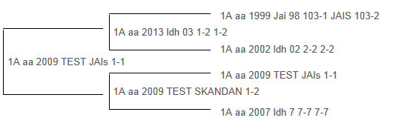

This is how displaying 3 Levels should look: 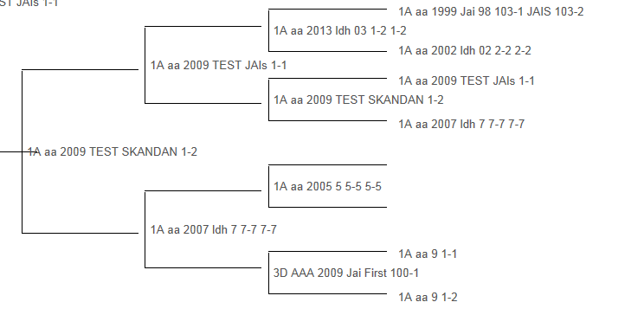

This is how displaying 4 Levels should look:
